**Assignment -1**

Q 1) Create Client_Master table:

create table client_master(

clientNo varchar(6),

name varchar(20),

address1 varchar(30),

address2 varchar(30),

city varchar(15),

pincode varchar(8),

state varchar(15),

baldue decimal(10,2)

);

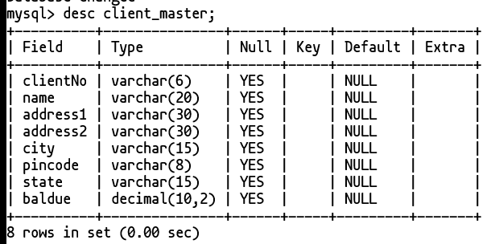

Q 2) Create Product_Master table:

create table product_master(

productNo varchar(6),

description varchar(15),

profitpercent double(4, 2),

unitmeasure varchar(10),

qtyonhand decimal(8),

recorderlv1 decimal(8),

sellprice decimal(8,2),

costprice decimal(8,2) );

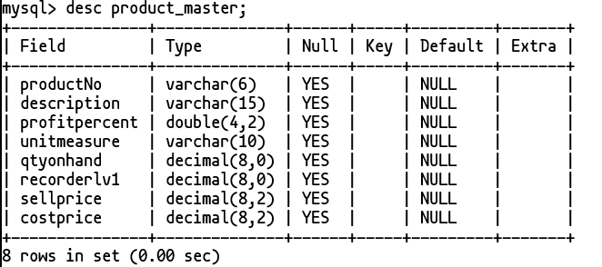

Q 3) Create Salesman_Master table:

create table salesman_master(

salesmanNo varchar(6),

salesmanName varchar(20),

address1 varchar(30),

address2 varchar(30),

city varchar(20),

pincode decimal(8),

state varchar(20),

salamt decimal(8,2),

tgttoget decimal(6,2),

ytdsales decimal(6,2),

remarks varchar(60) );

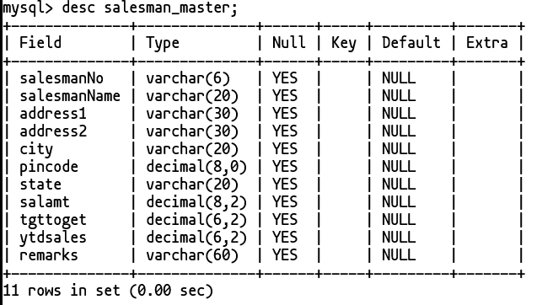

Q 4) Insert the following data into their respective tables:

• Data for CLIENT_MASTER Tables:

insert into client_master(clientNo, name, city, pincode, state, baldue) Values

('C00001', 'Ivan Bayross', 'Mumbai', 400054, 'Maharashtra', 15000),

('C00002', 'Mamta Muzumdar', 'Madras', 780001, 'Tamil Nadu', 0),

('C00003', 'Chhaya Bankar', 'Mumbai', 400057, 'Maharashra', 5000),

('C00004', 'Ashwini Joshi', 'Bangalore', 560001, 'Karnataka', 0),

('C00005', 'Hansel Colaco', 'Mumbai', 400060, 'Maharashtra', 2000),

('C00006', 'Deepak Sharma', 'Mangalore', 560050, 'Karnataka', 0);

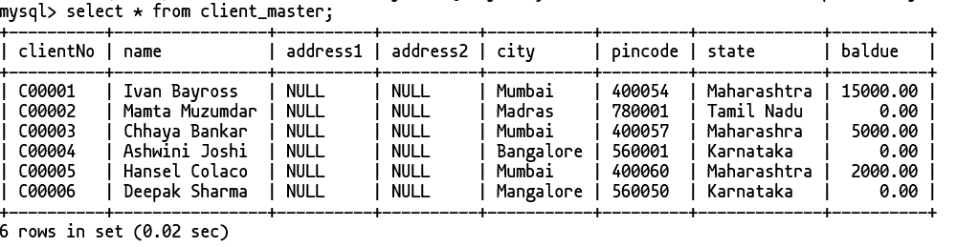

• Data for PRODUCT_MASTER tables:

insert into product_master (productNo, description, profitpercent, unitmeasure, qtyonhand, recorderlv1, sellprice, costprice) values

('P00001', 'T-Shirts', 5, 'Piece', 200, 50, 350, 250),

('P0345', 'Shirts', 6, 'Piece', 150, 50, 500, 350),

('P06734', 'Cotton Jeans', 5, 'Piece', 100, 20, 600, 450),

('P07865', 'Jeans', 5, 'Piece', 100, 20, 750, 500),

('P07868', 'Trousers', 2, 'Piece', 150, 50, 850, 550),

('P07885', 'Pull Overs', 2.5, 'Piece', 80, 30, 700, 450),

('P07965', 'Denim Shirts', 4, 'Piece', 100, 40, 350, 250),

('P07975', 'Lycra tops', 5, 'Piece', 70, 30, 300, 175),

('P08865', 'Skirts', 5, 'Piece', 75, 30, 450, 300);

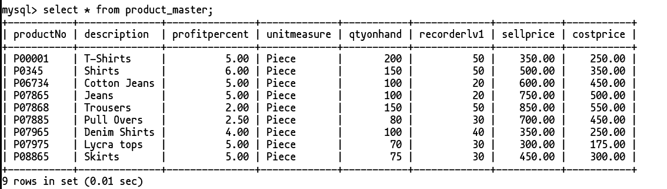

• Data for SALESMAN_MASTER tables:

insert into salesman_master(salesmanNo, salesmanName, address1, address2, city, pincode, state, salamt, tgttoget, ytdsales, remarks) values

('S0001', 'Aman', 'A/134', 'Worli', 'Mumbai', 400002, 'Maharashtra', 3000, 100, 50, 'Good'),

('S0002', 'Omkar', '65', 'Nariman', 'Mumbai', 400001, 'Maharashtra', 3000, 200, 100, 'Good'),

('S0003', 'Raj', 'P-7', 'Bandra', 'Mumbai', 400032, 'Maharashtra', 3000, 200, 100, 'Good'),

('S0004', 'Ashish', 'A/5', 'juhu', 'Mumbai', 400044, 'Maharashtra', 3500, 200, 150, 'Good');

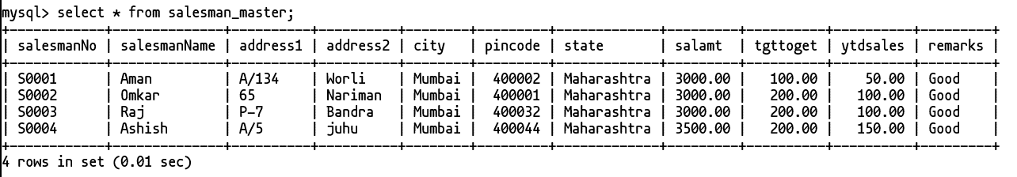

Q 3. Excercise on retrieving records from table

• Find out name of all clients.

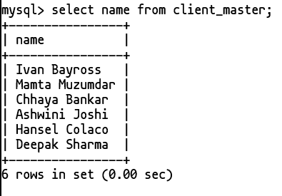

• Retrieve the entire contents of the Client_master table.



• Retrieve the list of names, city, and the state of all clients.

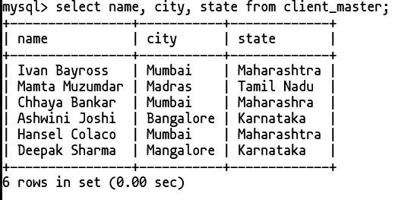

• List the various products available from the Product_Master table.

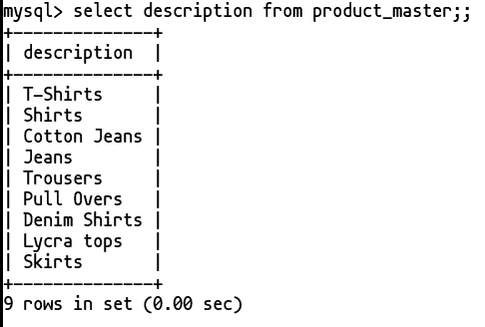

• List all the clients who are located in mumbai.

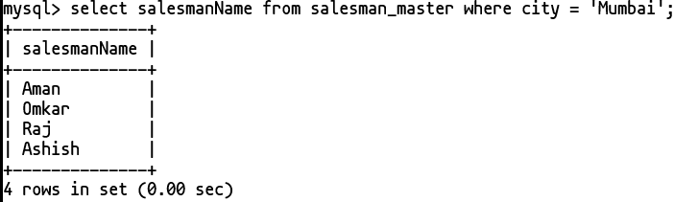

• Find the names of salesman who have a salary equal to Rs. 3000.

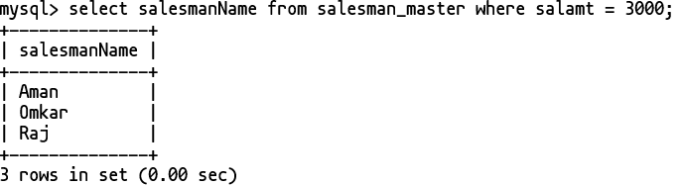

Q 4) Excercise on updating records in a table.

• Change the city of ClientNo 'C00005' to 'Banglore'.

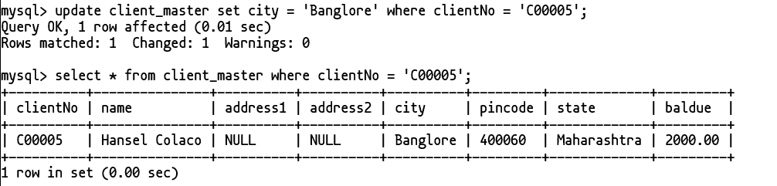

• Change the Baldue of ClientNo 'C00001' to Rs. 1000.

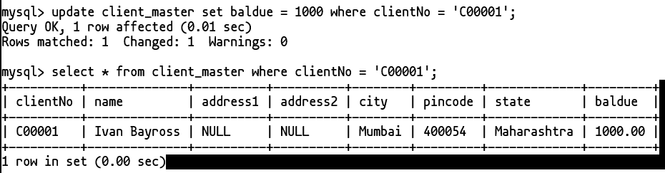

• Change the cost price of 'Trousers' to Rs. 950.00.

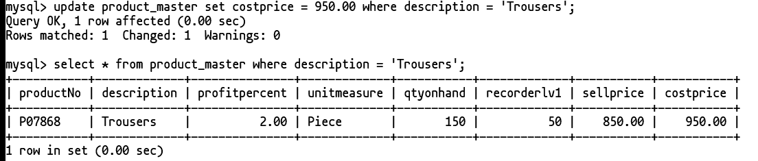

• Change the city of salesman to 'Pune'.

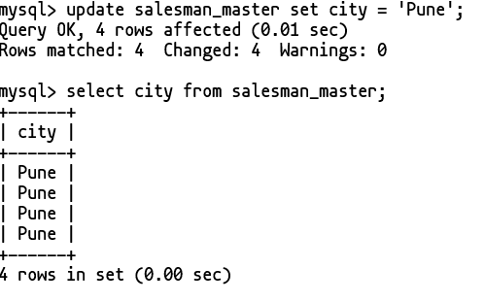

Q 5. Excercise on deleting records on table.

• Delete all salesman from the Salesman_Master whoes salary are equal to 3500.



• Delete all products from Product_Master where the quantity on hand is equal to 100.



• Delete from Client_Master where the column state holds the value 'Tamilnadu'.



Q 6. Excercise on altering the table structure

• Add a column called 'Telephone' of datatype 'number' and size = '10' to the Client_Master table.

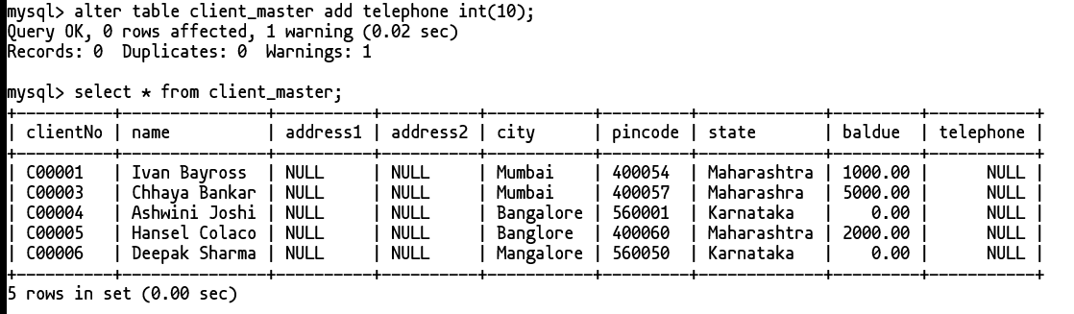

• Change the size of SellPrice column in Product_Master to 10,2.

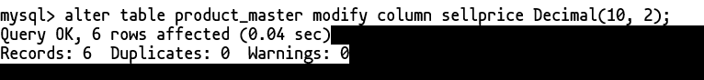

Q 7. Excersice on deleting the table structure alongwith the data.

• Destroy the table Client_Master along with its data.



8. Excercise on renaming the table.

a. Change the name of Salesman_Master table to Sman_Mast.

